**TUGAS PRAKTIKUM**

**PENGEMBANGAN APLIKASI WEB**

**MODUL 3**

**“PHP Forms”**



**Disusun Oleh:**

Nama : Ari Andi Mustofa

NIM : 200411100133

Kelas : Basis Data II-4B

**Dosen Pengampu:**

Nama : Ach. Khozaimi,S.Kom,M.Kom.

NIP : 198609262014041001

**Asisten Praktikum:**

Nama : Alief Fadhilah Athallariq

NIM : 180411100028

**PRODI TEKNIK INFORMATIKA**

**JURUSAN TEKNIK INFORMATIKA  
FAKULTAS TEKNIK**

**UNIVERSITAS TRUNOJOYO MADURA**

**2022**

**Tugas Praktikum :**

1. Buatlah sebuah form yang berisi name, e-mail, website, comment, gender, tombol submit, dan tampilan output dari inputan yang dimasukkan seperti berikut:

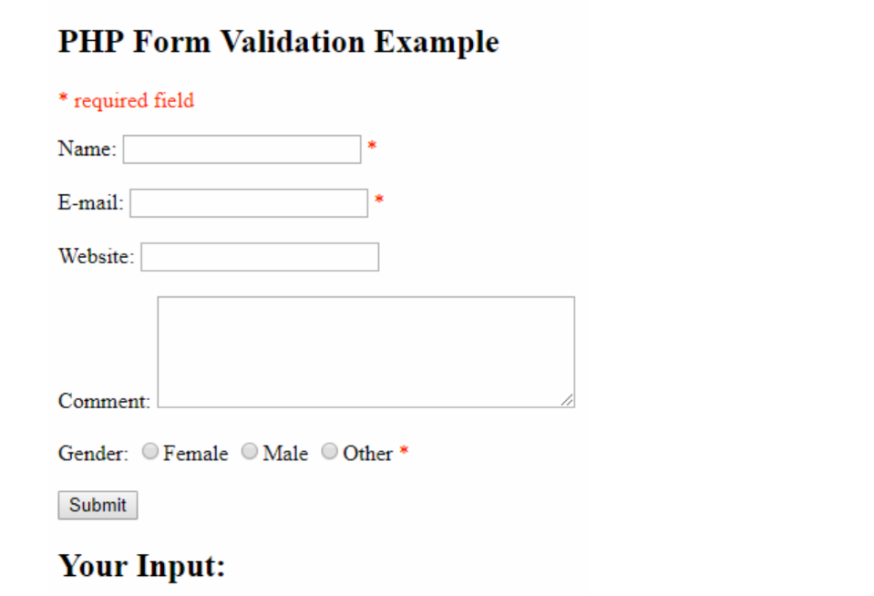

Code :

<!DOCTYPE html>

<html lang="en">

<head>

    <meta charset="UTF-8">

    <meta http-equiv="X-UA-Compatible" content="IE=edge">

    <meta name="viewport" content="width=device-width, initial-scale=1.0">

    <title>Nomer 2</title>

</head>

<body>

<h2>PHP Form Validation Example</h2>

    <p style="color: red;">* required field</p>

    <form action="#" method="POST">

        Name: <input type="text" name="name"><span style="color: red;"> *</span> <br><br>

        E-mail: <input type="text" name="email"> <span style="color: red;"> *</span> <br><br>

        Website: <input type="text" name="website"> <br><br>

        Comment: <textarea name="" id="" cols="35" rows="5" name="comment"></textarea><br><br>

        Gender: <input type="radio" name="gender" id="female">Female

                <input type="radio" name="gender" id="male">Male

                <input type="radio" name="gender" id="other">Other

        <span style="color: red;"> *</span> <br><br>

        <button type="submit">Submit</button>

        <h2>Your Input :</h2>

    </form>

</body>

</html>

Hasil :

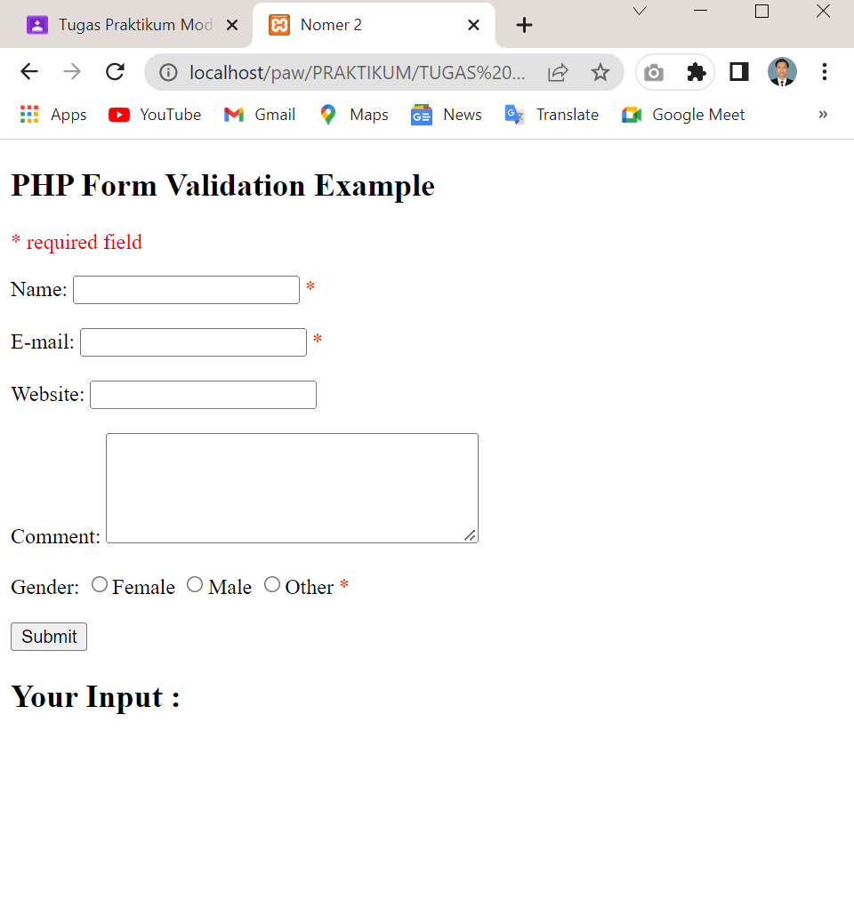

1. Buatlah validasi terhadap form, apabila form disubmit dalam keadaan kosong maka akan muncul pesan seperti berikut:

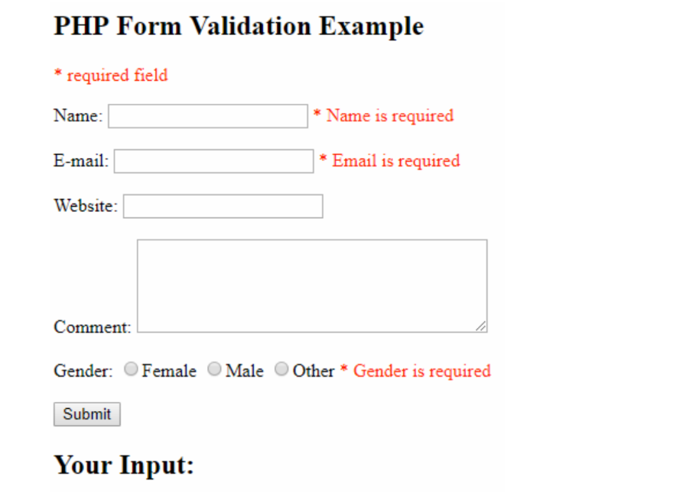

Code :

<!DOCTYPE html>

<html lang="en">

<head>

    <meta charset="UTF-8">

    <meta http-equiv="X-UA-Compatible" content="IE=edge">

    <meta name="viewport" content="width=device-width, initial-scale=1.0">

    <title>Nomer 2</title>

</head>

<body>

    <?php

        // define variables and set to empty values

        $nameError = $emailError = $genderError = $websiteError = "";

        $name = $email = $gender = $comment = $website = "";

        if ($_SERVER["REQUEST_METHOD"] == "POST") {

            if (empty($_POST["name"])) {

                $nameError = "Name is required";

            } else {

                $name = test($_POST["name"]);

            }

            if (empty($_POST["email"])) {

                $emailError = "Email is required";

            } else {

                $email = test($_POST["email"]);

            }

            if (empty($_POST["website"])) {

                $website = "";

            } else {

                $website = test($_POST["website"]);

            }

            if (empty($_POST["comment"])) {

                $comment = "";

            } else {

                $comment = test($_POST["comment"]);

            }

            if (empty($_POST["gender"])) {

                $genderError = "Gender is required";

            } else {

                $gender = test($_POST["gender"]);

            }

        }

*function* test($data) {

          $data = trim($data);

          $data = stripslashes($data);

          $data = htmlspecialchars($data);

        }

    ?>

    <h2>PHP Form Validation Example</h2>

    <p style="color: red;">* required field</p>

    <form action="<?php echo $_SERVER["PHP_SELF"];?>" method="POST">

        <div>

        Name: <input type="text" name="name" value="<?php echo $name ;?>"><span style="color: red;" class="error" > * <?php echo $nameError; ?></span> <br><br>

        </div>

        <div>

        E-mail: <input type="text" name="email" value="<?php echo $email ;?>"> <span style="color: red;" class="error"> * <?php echo $emailError ;?></span> <br><br>

        </div>

        <div>

        Website: <input type="text" name="website" value="<?php echo $website ;?>"><span style="color: red;" class="error"> <?php echo $websiteError ;?></span> <br><br>

        </div>

        <div>

        Comment: <textarea name="comment" id="" cols="35" rows="5" name="comment" ></textarea><?php echo $comment; ?><br><br>

        </div>

        <div>

        Gender: <input type="radio" name="gender" id="female" >Female

                <input type="radio" name="gender" id="male" >Male

                <input type="radio" name="gender" id="other">Other

        <span style="color: red;" class="error"> *<?php echo $genderError; ?></span> <br><br>

        </div>

        <button type="submit">Submit</button>

    </form>

    <h2>Your Input :</h2>

</body>

</html>

Hasil :

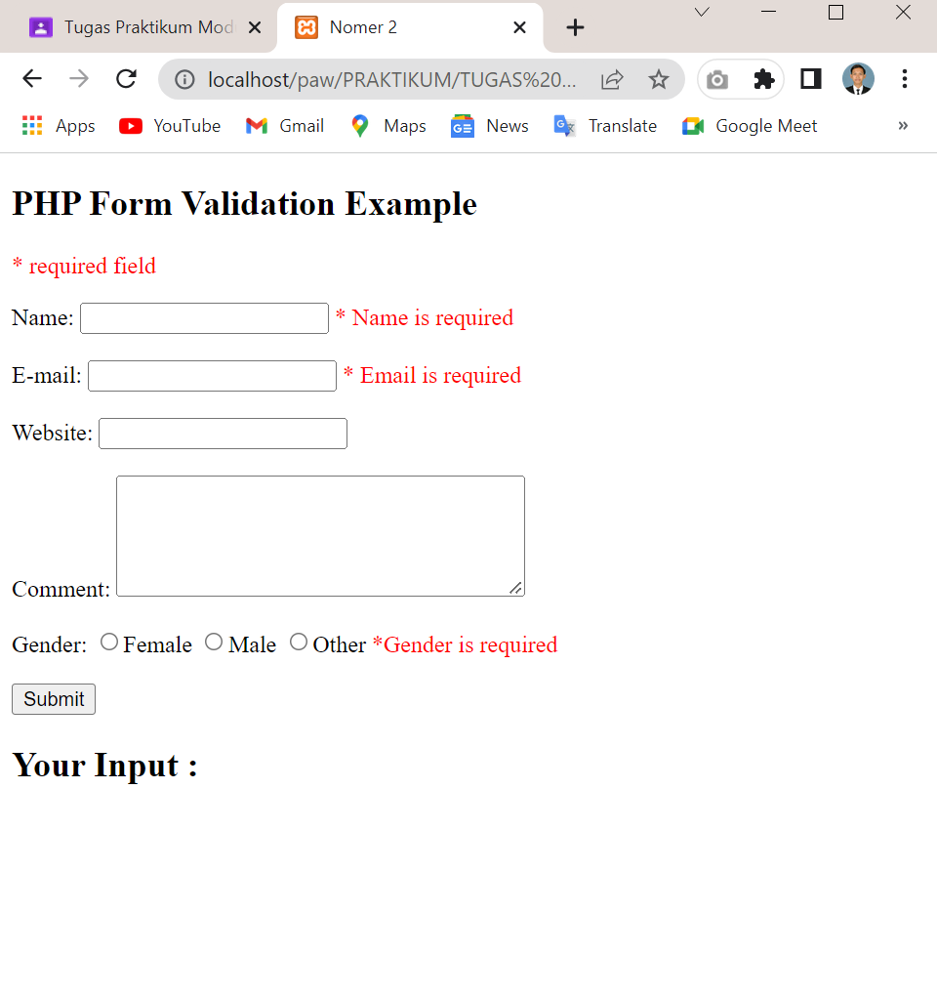

1. Berikan validasi terhadap kesalahan input pada name, e-mail dan website, seperti contoh berikut:

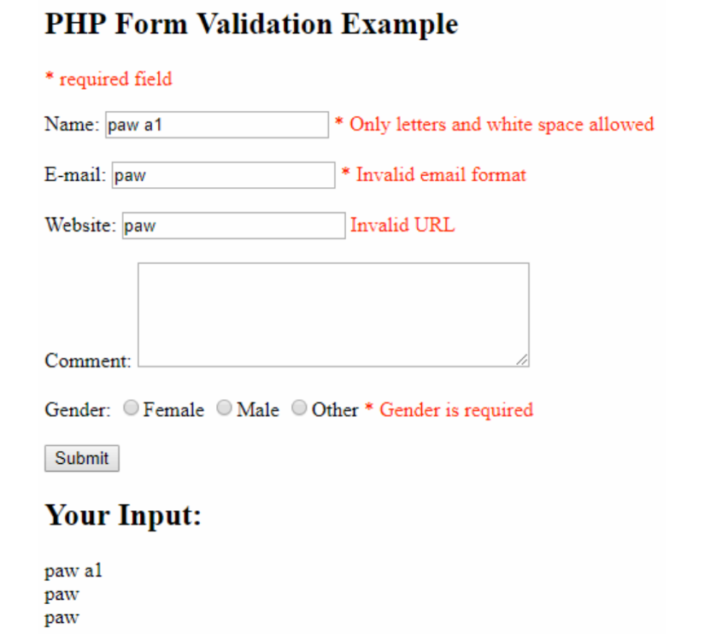

Code :

<!DOCTYPE html>

<html lang="en">

<head>

    <meta charset="UTF-8">

    <meta http-equiv="X-UA-Compatible" content="IE=edge">

    <meta name="viewport" content="width=device-width, initial-scale=1.0">

    <title>Nomer 3</title>

</head>

<body>

    <?php

        // define variables and set to empty values

        $nameError = $emailError = $genderError = $websiteError = "";

        $name = $email = $gender = $comment = $website = "";

        if ($_SERVER["REQUEST_METHOD"] == "POST") {

            if (empty($_POST["name"])) {

                $nameError = "Name is required";

            } else {

                $name = test($_POST["name"]);

                if (!preg_match("/^[a-zA-Z ]*$/",$name)) {

                    $nameError = "Only letters and white space allowed";

                }

            }

            if (empty($_POST["email"])) {

                $emailError = "Email is required";

            } else {

                $email = test($_POST["email"]);

                if (!filter_var($email, FILTER_VALIDATE_EMAIL)) {

                    $emailError = "Invalid email format";

                }

            }

            if (empty($_POST["website"])) {

                $website = "";

            } else {

                $website = test($_POST["website"]);

                if (!preg_match("/\b(?:(?:https?|ftp):\/\/|www\.)[-a-z0-9+&@#\/%?=~_|!:,.;]*[-a-z0-9+&@#\/%=~_|]/i",$website)) {

                    $websiteError = "Invalid URL";

                }

            }

            if (empty($_POST["comment"])) {

                $comment = "";

            } else {

                $comment = test($_POST["comment"]);

            }

            if (empty($_POST["gender"])) {

                $genderError = "Gender is required";

            } else {

                $gender = test($_POST["gender"]);

            }

        }

*function* test($data) {

          $data = trim($data);

          $data = stripslashes($data);

          $data = htmlspecialchars($data);

          return $data;

        }

    ?>

    <h2>PHP Form Validation Example</h2>

    <p style="color: red;">* required field</p>

    <form action="<?php echo htmlspecialchars($_SERVER["PHP_SELF"]);?>" method="POST">

        Name: <input type="text" name="name"><span style="color: red;" class="error" > * <?php echo $nameError; ?></span> <br><br>

        E-mail: <input type="text" name="email" > <span style="color: red;" class="error"> * <?php echo $emailError ;?></span> <br><br>

        Website: <input type="text" name="website" ><span style="color: red;" class="error"> <?php echo $websiteError ;?></span> <br><br>

        Comment: <textarea name="comment" id="" cols="35" rows="5" name="comment" ></textarea><br><br>

        Gender: <input type="radio" name="gender" id="female" >Female

                <input type="radio" name="gender" id="male" >Male

                <input type="radio" name="gender" id="other" >Other

        <span style="color: red;" class="error"> *<?php echo $genderError; ?></span> <br><br>

        <button type="submit">Submit</button>

    </form>

    <?php

        echo "<h2>Your Input:</h2>";

        echo $name."<br>";

        echo $email."<br>";

        echo $website."<br>";

    ?>

</body>

</html>

Hasil :

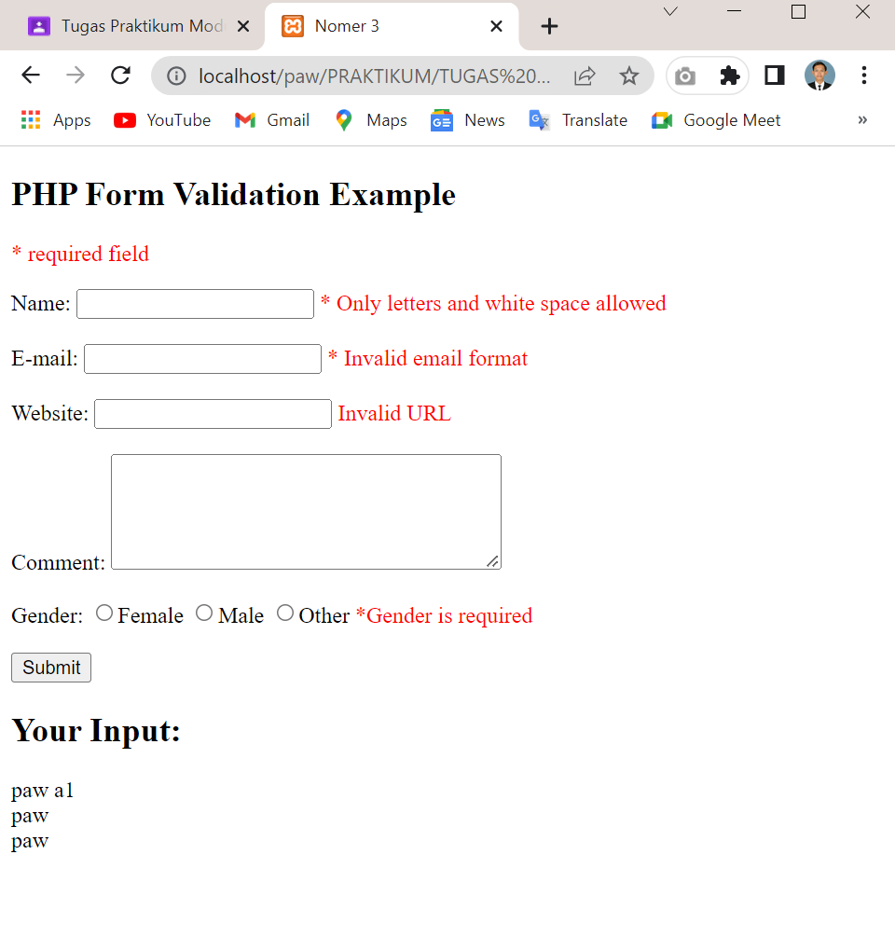

1. Berikan kondisi pada form apabila dilakukan submit maka value yang diinputkan pada field tidak hilang.

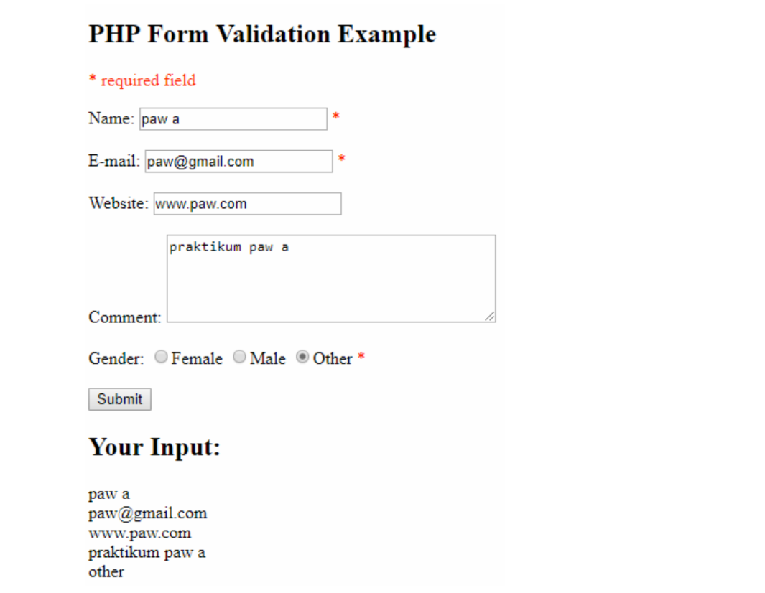

Code :

<!DOCTYPE html>

<html lang="en">

<head>

    <meta charset="UTF-8">

    <meta http-equiv="X-UA-Compatible" content="IE=edge">

    <meta name="viewport" content="width=device-width, initial-scale=1.0">

    <title>Nomer 4</title>

</head>

<body>

    <?php

        // define variables and set to empty values

        $nameError = $emailError = $genderError = $websiteError = "";

        $name = $email = $gender = $comment = $website = "";

        if ($_SERVER["REQUEST_METHOD"] == "POST") {

            if (empty($_POST["name"])) {

                $nameError = "Name is required";

            } else {

                $name = test($_POST["name"]);

                if (!preg_match("/^[a-zA-Z ]*$/",$name)) {

                    $nameError = "Only letters and white space allowed";

                }

            }

            if (empty($_POST["email"])) {

                $emailError = "Email is required";

            } else {

                $email = test($_POST["email"]);

                if (!filter_var($email, FILTER_VALIDATE_EMAIL)) {

                    $emailError = "Invalid email format";

                }

            }

            if (empty($_POST["website"])) {

                $website = "";

            } else {

                $website = test($_POST["website"]);

                if (!preg_match("/\b(?:(?:https?|ftp):\/\/|www\.)[-a-z0-9+&@#\/%?=~_|!:,.;]*[-a-z0-9+&@#\/%=~_|]/i",$website)) {

                    $websiteError = "Invalid URL";

                }

            }

            if (empty($_POST["comment"])) {

                $comment = "";

            } else {

                $comment = test($_POST["comment"]);

            }

            if (empty($_POST["gender"])) {

                $genderError = "Gender is required";

            } else {

                $gender = test($_POST["gender"]);

            }

        }

*function* test($data) {

          $data = trim($data);

          $data = stripslashes($data);

          $data = htmlspecialchars($data);

          return $data;

        }

    ?>

    <h2>PHP Form Validation Example</h2>

    <p style="color: red;">* required field</p>

    <form action="<?php echo htmlspecialchars($_SERVER["PHP_SELF"]);?>" method="POST">

        Name: <input type="text" name="name" value="<?php echo $name ;?>"><span style="color: red;" class="error" > * <?php echo $nameError; ?></span> <br><br>

        E-mail: <input type="text" name="email" value="<?php echo $email ;?>"> <span style="color: red;" class="error"> * <?php echo $emailError ;?></span> <br><br>

        Website: <input type="text" name="website" value="<?php echo $website ;?>"><span style="color: red;" class="error"> <?php echo $websiteError ;?></span> <br><br>

        Comment: <textarea name="comment" id="" cols="35" rows="5" name="comment" ><?php echo $comment; ?></textarea><br><br>

        Gender: <input type="radio" name="gender" id="female" value="Female"<?php if(isset($gender) && $gender=="Female") echo "checked"?>>Female

                <input type="radio" name="gender" id="male" value="Male"<?php if(isset($gender) && $gender=="Male") echo "checked"?>>Male

                <input type="radio" name="gender" id="other" value="Other"<?php if(isset($gender) && $gender=="Other") echo "checked"?>>Other

        <span style="color: red;" class="error"> *<?php echo $genderError; ?></span> <br><br>

        <button type="submit">Submit</button>

    </form>

    <?php

        echo "<h2>Your Input:</h2>";

        echo $name."<br>";

        echo $email."<br>";

        echo $website."<br>";

        echo $comment."<br>";

        echo $gender."<br>";

    ?>

</body>

</html>

Hasil :

